Assist.Prof.Dr. Turgay ALTILAR 06/02/2006
Lec.Dr. Yaşar ERENLER
Lec. Binnur KURT
INTRODUCTION TO SCIENTIFIC AND ENGINEERING COMPUTING
FINAL EXAM
(2 Hour-Exam. 3 Pages and 4 Questions. Give your answer inside the corresponding box.)

Q.1) (5) Assume that you have an array defined as
int p[]={1,1,2,7,15,…,48} ;
How can you read the value of the last element, i.e. the cell storing 48?

Q.2) (25) Which of the following statements are correct? What is the output if wrong statements are discarded?
double *p;
double q[10]={0.,1.,2.,3.,4.,5.,6.,7.,8.,9.} ;

C++ version | Output | C version
cout << *(&q[5]) ; |  | printf(“%f”,*(&q[5]));
cout << *(&q[3]+4) ; |  | printf(“%f”,*(&q[3]+4));
cout << *q ; |  | printf(“%f”,*q);
cout << *(q) ; |  | printf(“%f”,*(q));
cout << *(q+4) ; |  | printf(“%f”,*(q+4));
cout << (&q[8]-&q[3]) ; |  | printf(“%f”, (&q[8]-&q[3]));
cout << *(p=q+3) ; |  | printf(“%f”,*(p=q+3));
cout << (p=q+3)[5] ; |  | printf(“%f”,(p=q+3)[5]);

Q.3) (30) Student information is represented by the following structure
struct SStudent {
char name[36] ;
long studentID;
int grade ;
char letterGrade[3];
};
typedef struct SStudent TStudent ;
typedef struct SStudent* PStudent ;
- (5) Initialize the following array with two student information: (Michael Scofield, 40020336, 97,AA) and (Lincoln Burrows, 40040502, 73,BB):
TStudent bil105e[]={

};
- (25) Write a function which takes an array of TStudent and the array size and then calculates the letter grades automatically assuming a bell-curve distribution using the following equation where m denotes the mean and σ denotes the standard deviation. You are allowed to use only ONE if-statement. Hint: Use two-dimensional array of size 8-by-2.
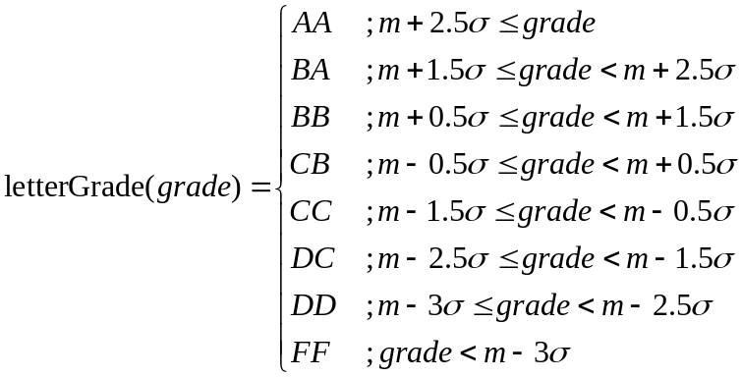 , where 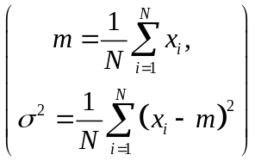.

void computeLetterGrade(PStudent course, int length){

}
Q.4) (40) Write a function which takes a two-dimensional array of type int and its size, then returns true if there is NO linearly dependent rows or columns and false otherwise. Example: The following matrix has linearly dependent rows and columns:
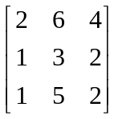
If you multiply the second row by 2 you get the first row, or if you multiply the first column by 2 you obtain the third column. If you call the function with the matrix, the function should return false.
{
isLinearlyIndependent

}

